The following steps were taken to manually validate the FEP member linking to claims:

* Write a SQL Query to find mis-matched claims. (Step 1)
* Locate claims that were linked to members each of the seven ways specified by the Acceptance Criteria. (Step 2)
* Manually validate that the linking attempt number that was used was correct. (Step 3)

**Step 1**: *SQL Query located in the associated file also attached to this card.*This query grabs the MBR ID that is associated to the claim (table a)  
and joins it to a table created (table b)  
  
Table b is created by performing the spider merge, looking at the claim records of the first name, last name, date of birth, and middle initial  
and associating that to an appropriate member id based on ranking the 7 merge attempts, and finding the lowest ranked merge attempt that returns exactly one mbr_id.  
  
Then it links ‘table a’ with ‘table b’ on clm_med_detl_id where a.mbr_id != b.mbr_id, returning all of the records that are incorrectly linked.   
As that returned record, it returns MBR_LINKED_TO_CLAIM, MBR_THAT_SHOULD_BE_ON_CLAIM, MERGE_THAT_SHOULD_BE_USED, and CLM_MED_DETL_ID.

**Result of Step 1:** Because zero rows were returned from the query, all of the rows met the acceptance criteria of the member linking to claims.

**Step 2**: *Table identifies the Linking Attempt number, SUB_ID, and CLM_MED_DETL_ID of the cases that were identified.*

|  |  |  |  |
| --- | --- | --- | --- |
| Link Attempt | Linking Criteria | SUB_ID | CLM_MED_DETL_ID |
| 1 | SUB_ID, First Name, Last Name, Middle Initial, DOB | R50124899 | 1472393919 |
| 2 | SUB_ID, First Name, Last Name, DOB | R59087148 | 1472560381 |
| 3 | SUB_ID, First Name, Last Name | R01743643 | 1472437933 |
| 4 | SUB_ID, First Name | R59747664 | 1472590984 |
| 5 | SUB_ID, Last Name | R59292843 | 1472571020 |
| 6 | SUB_ID, DOB | R50027989 | 1472471205 |
| 7 | SUB_ID, MBR_RELSHP_TO_SUB = ‘M’ | R23383638 | 1472464777 |

**Step 3**: *Detailed explanations of the situation described in step 2.*  
Link Attempt 1:  
*Source claim:*



*Target Claim:*



*Associated Member:*



Since the MBR information is all lined up, First Name, Last Name, Middle Initial, DOB and Contract Number (SUB_ID_TXT), the claim was appropriately.

Link Attempt 2:

*Source claim:*



*Target Claim:*

*Associated Contract:*



MBR 1470397363 is the only MBR on his contract. When the source claim came in with no middle initial, it failed the first attempt, but succeeded on the link by first name, last name and DOB.

Link Attempt 3:

*Source claim:*



*Target Claim:*



*Associated Contract:*



Notice that the DOB on the incoming claim does not match the DOB that we have in our member table (associated contract). This caused it to fail the first two attempts, but matched the third attempt for First name and Last name.

Link Attempt 4:

*Source claim:*



*Target Claim:*



*Associated Contract:*

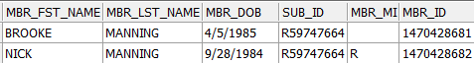

The last name on this contract is not the same last name as the claim coming in. Thus it would fail the first 3 linking attempts. When it gets to first name, the claim is appropriately associated.

Link Attempt 5:

*Source claim:*



*Target Claim:*



*Associated Contract:*



The incoming claim does not have the same first name as any of our records for that contract. Thus it failed the first 4 attempts. But it successfully associated to the MBR by Last Name.

Link Attempt 6:

*Source claim:*



*Target Claim:*



*Associated Contract:*

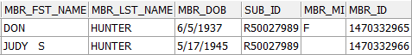

The incoming claim does not have the same first name as any of the MBRs on that contract in our records. This is because MBR 1470332966 has three spaces between Judy and S, whereas the incoming claim has a single space. Then when the attempt based on last name is run, there are multiple members with a matching last name. So it then matched to our member on DOB.

Link Attempt 7:

*Source claim:*



*Target Claim:*



*Associated Contract:*

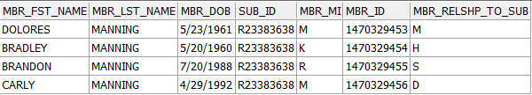

The Contract that we have for this claim does not have anyone matching DELORES. When it attempted to match via last name, there were multiple last name matches, so it could not find a singular member to associate it to. It also does not have anyone with a DOB of 5/23/2013. Thus it was associated to the main subscriber